

**Middle East Technical University**

**Electrical-Electronics Engineering Department**

**EE430 Digital Signal Processing Term Project (2017-2018 Fall Semester)**

**Group X**

**Mehmet Mert Beşe 2093482**

**Berk İskender 2031920**

**Comments on spectrogram computation and its utilization:**

Before skipping to the works related to phase 2 of the project, we want to include details about how to select overlap amount and the purpose of windowing while using spectrogram function that we have constructed.

While obtaining the spectrogram of a signal, there is a tradeoff between spectral leakage and spectral resolution. A window that results in less spectral leakage has smaller side lobes in its Fourier transform. However, it distorts the input signal unavoidably because of the increased main lobe width in its Fourier transform. Increased main lobe width limits the spectral resolution per window length since we use convolution in the frequency domain while windowing.

To increase the resolution, window length can be increased. Being an almost optimal value, we tried to use %50 overlapping per window while displaying our results.

1. **Reducing the Number of Time Samples:**

In this part of the project, we are asked to reduce the total amount of time samples in a periodical manner (downsampling) with different ratios. (e.g. discard one of each N time domain samples) To perform this operation, we used built-in functions of MATLAB which are “downsample” and “decimate”.

**Effects of increasing downsampling rate:** As downsampling factor increases and exceeds the value of pi/W (W is the highest frequency present in the signal) aliasing starts to occur. As a result of this fact, starting from the higher frequencies, signal gets aliased (distorted). When we apply this effect on linear chirp with sufficiently high bandwidth (m value in the chirp) or any signal that includes higher frequencies, signal has doubled higher frequency components due to aliasing. This effect can be easily seen in linear chirp case. As we increase the ratio, high frequency parts starts to get repeated in the spectrogram which means that the power of those corresponding frequencies are doubled.

As the downsampling rate incerases, signal becomes shorter and its speed gets multiplied by the downsampled factor when played using the sampling frequency rate. However, if the playing frequency is fs*1/downsampling rate, speed remains constant while doing playback.

Moreover, same effects can be observed in the recorded sound signal and input data file when we apply downsampling and decimation separately. As we apply downsampling, frequencies present in those signals are stretched towards the higher values (proportional to the downsampling factor). When this factor times maximum frequency of the signal exceeds the half of the sampling frequency, aliasing starts to occur. Decimation nearly eliminates all of the aliasing effect in those two cases too.

**Avoiding aliasing using decimation:** In order to avoid this aliasing effect, decimation should be applied on the signal instead of downsampling. Decimation initially filters the signal (low pass filtering) with a pi/M cutoff frequency in order to avoid aliasing after stretching the frequency domain response due to downsampling. This technique may also result in loss of some high frequency components in the filtering stage while avoiding aliasing. However, losing such components is better than experiencing aliasing on them. Results obtained using decimation are added in order to display the behavior explained above.

**Applying fractional downsampling factors:** To use fractional downsampling factors, upsampling should be done first. For instance, if the signal is to be “downsampled” by a factor of 2.5, it should be upsampled by 2 firstly and downsampled by 5 afterwards. While doing so, we need to use a “low pass filter” after upsampling in order to eliminate frequencies higher than the W/L, where W is the bandlimit of the input signal. By doing so, there will not be repetitions at the output of the downsampler. This can be also achieved by applying decimation on the upsampled signal. By comparing both results of 2.5 factor downsampling, one can easily see that decimation provides a nearly ideal result. As an interpolator, zero order hold is used while performing upsampling.

**Listening experience for produced signals (Audio comparison):** For the sound file inputs, as we increase the downsampling rate, quality of the sound decreases. Also, aliasing starts to occur for smaller rates for signals that include higher frequencies. When decimation is used to avoid this effect, a muffled sound is heard with lower frequencies because it suppresses higher frequencies as explained and some frequencies are completely eliminated afterwards. Aliasing effect can be easily heard when listening to linear chirp cases.

**Results using decimation in time-domain:**

Results for 3 different signals are listed below:

1. Linear Chirp signal, starting from 0 to 10 kHz, 5 seconds long: While obtaining spectrograms, Hamming window is used. Overlap amount is 50% in the figures for each window.

* Time Domain signals for different downsampling rates:

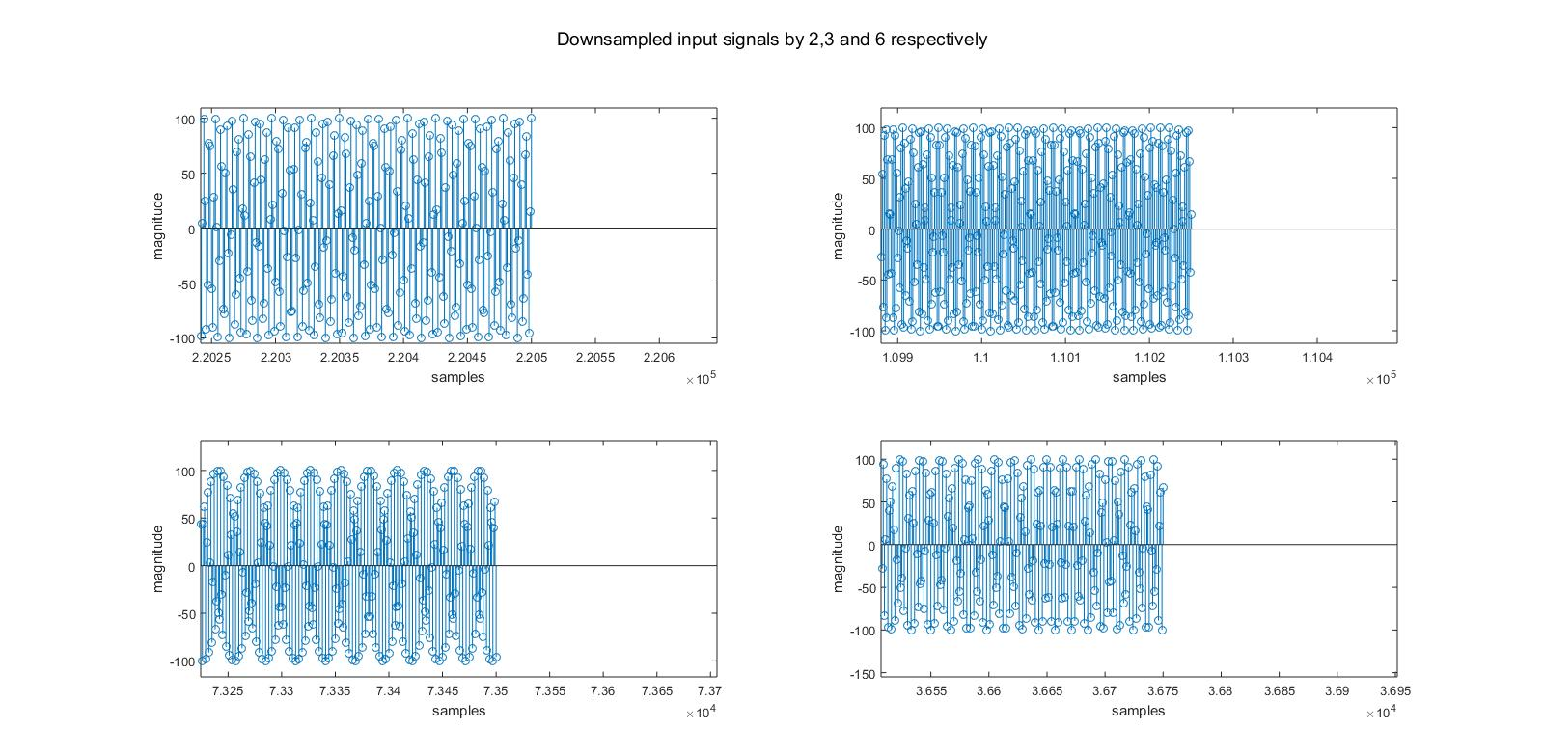

Figure: Fractions of time domain linear chirp signals (ends of the signals are extracted as fractions for better visualization)

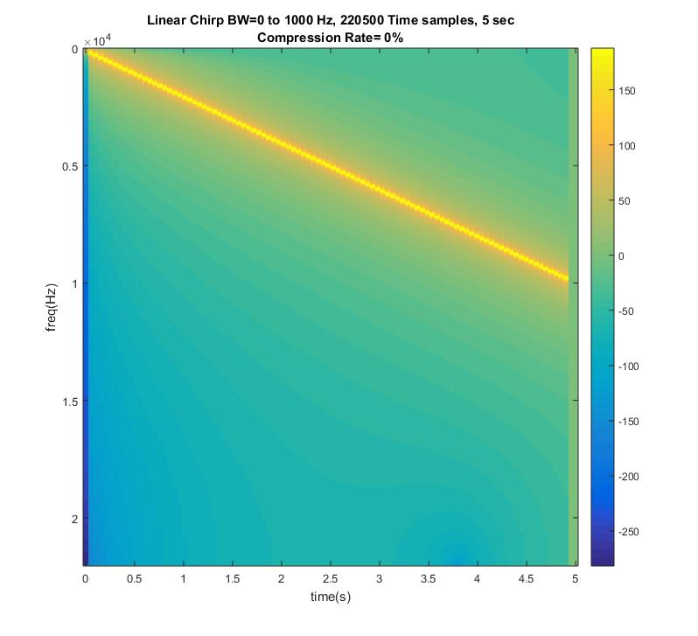

Figure: Spectrogram of the original linear chirp signal

* **Results obtained using downsampling:**

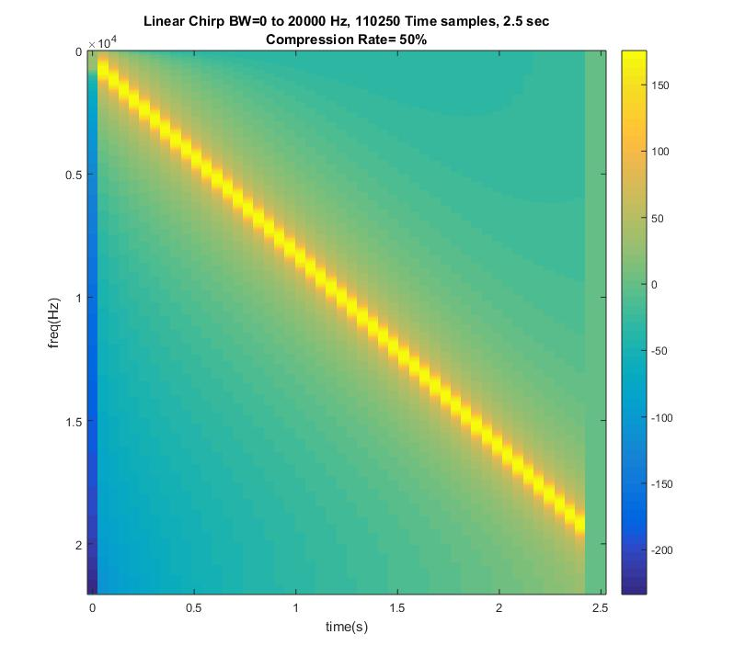

Figure: Spectrogram of the linear chirp signal downsampled by 2 (Frequency streches to 20 kHz which is equal to 10 kHz*downsampling rate)

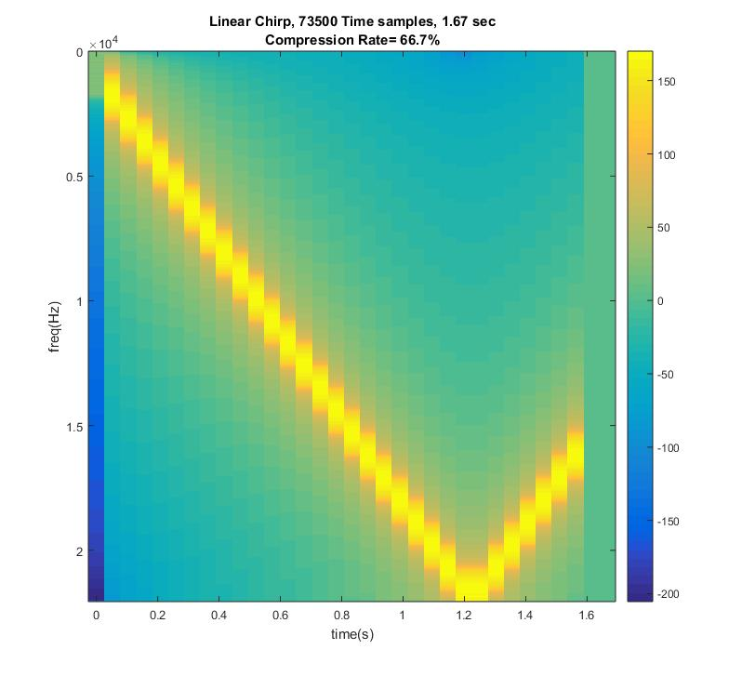

Figure: Spectrogram of the linear chirp signal downsampled by 3 (aliasing occurs for frequencies larger than fs/2)

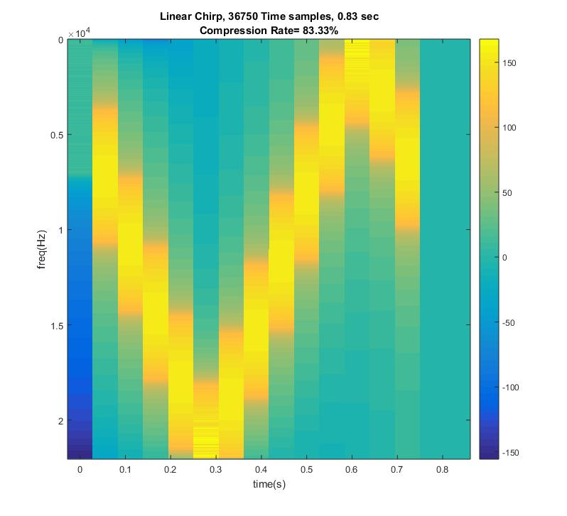

Figure: Spectrogram of the linear chirp signal downsampled by 6 (aliasing occurs for frequencies larger than fs/2)

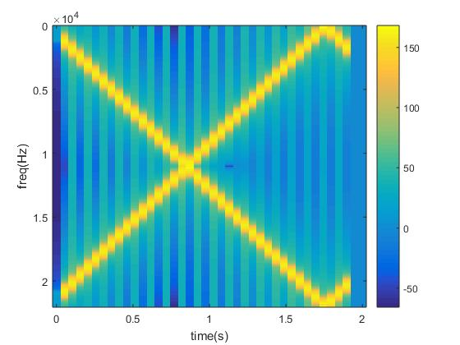

Figure: Spectrogram of the linear chirp signal downsampled by 2.5

As it can be seen in the figure, repetitions occur in the frequency domain because a LPF after the upsampling process is not used.

**Results obtained using decimation:**

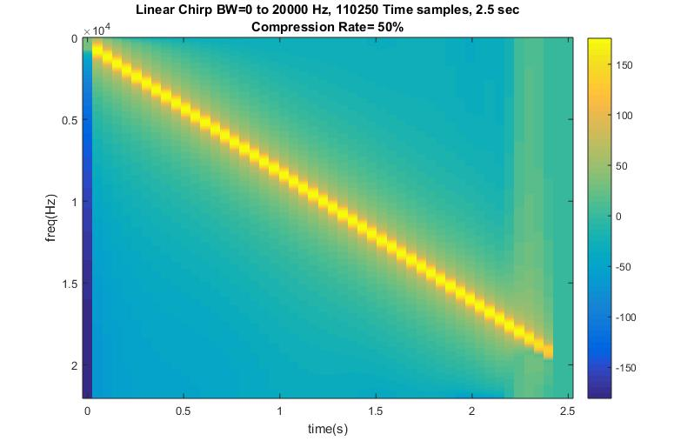

Figure: Spectrogram of the linear chirp signal decimated by 2

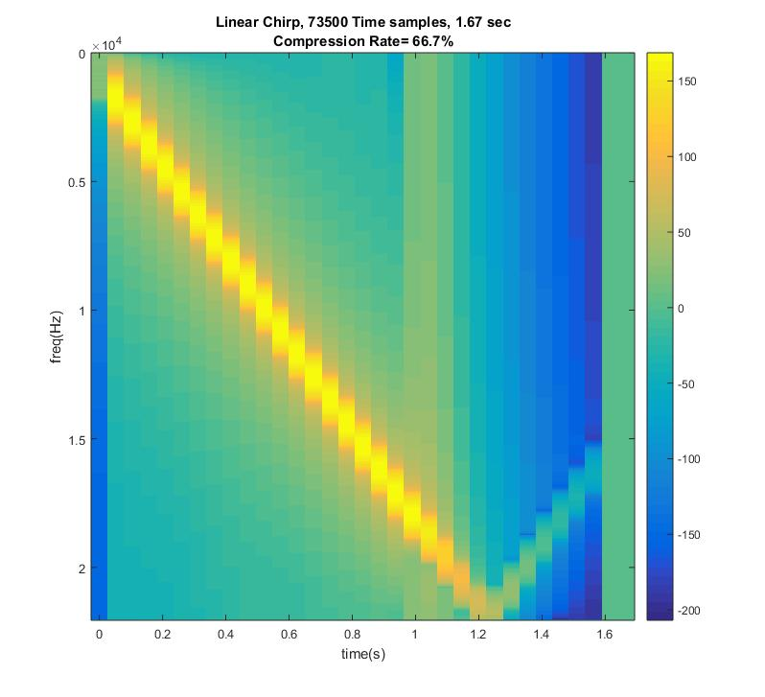

Figure: Spectrogram of the linear chirp signal decimated by 3 (frequencies which cause aliasing are suppressed by LPF)

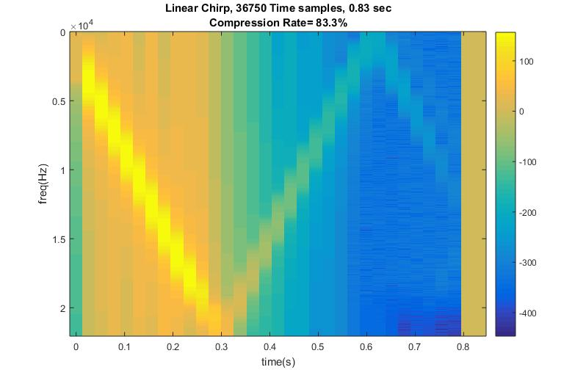

Figure: Spectrogram of the linear chirp signal decimated by 6 (frequencies which cause aliasing are suppressed by LPF)

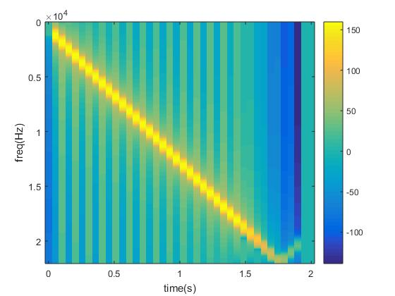

Figure: Spectrogram of the linear chirp signal decimated by 2.5 (frequencies which cause aliasing are suppressed by LPF)

1. **Sound file input:**

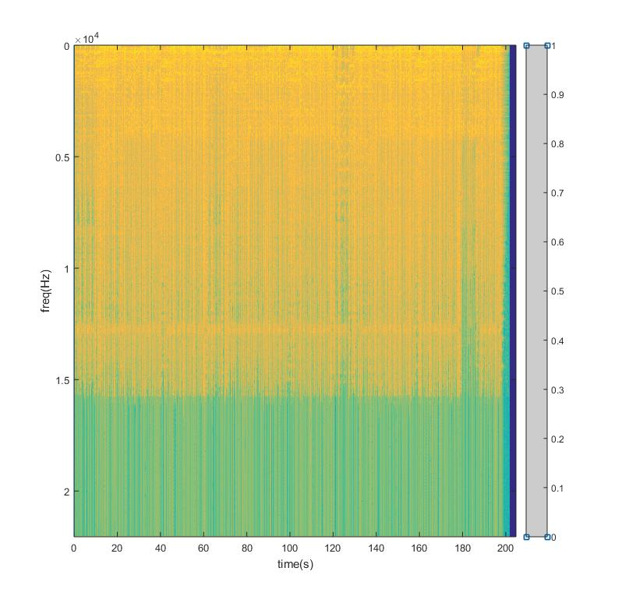

Figure: Spectrogram of the sound file input signal

* **Decimation applied on a sound file input:**

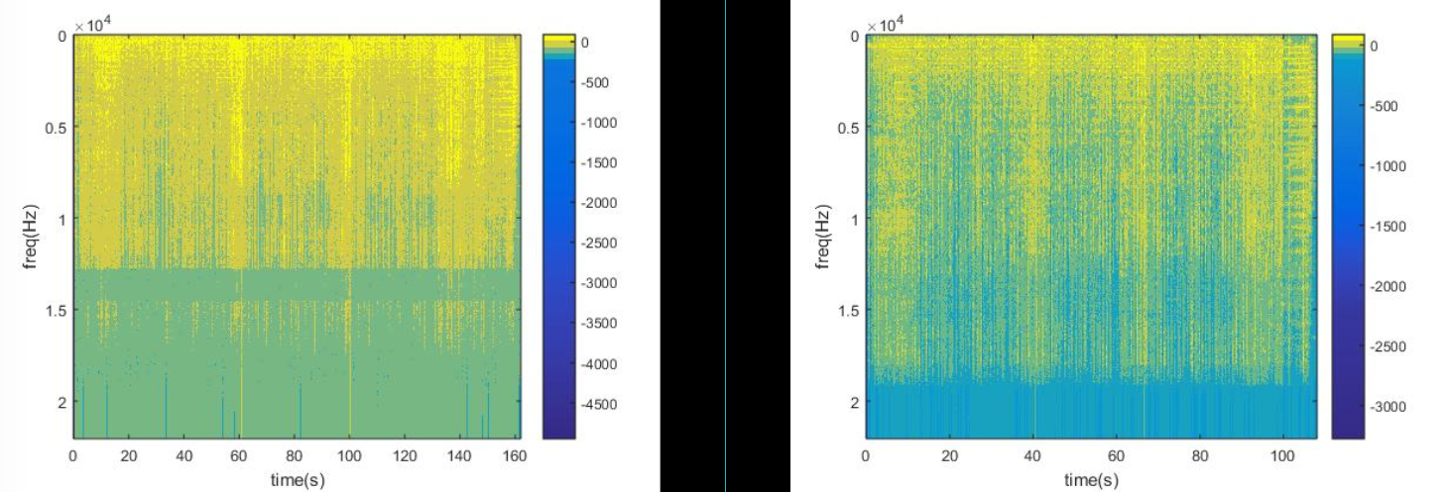

Figure: Spectrogram of the sound file input signal decimated by 2 and 3 respectively (Higher frequencies are suppressed by LPF)

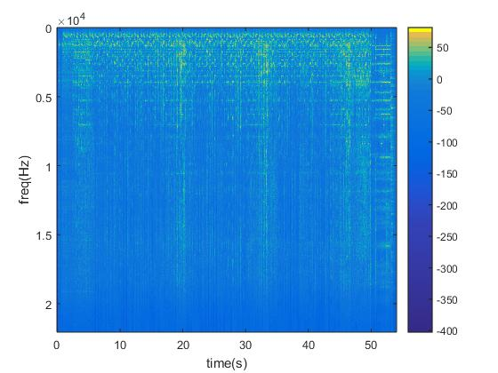

Figure: Spectrogram of the sound file input signal decimated by 6

* **Downsampling applied on a sound file input:**

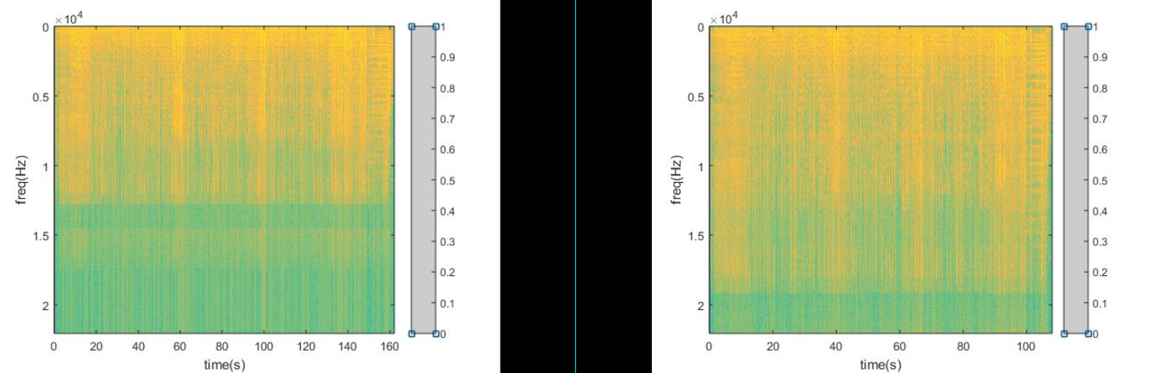

Figure: Spectrogram of the sound file input signal downsampled by 2 and 3 respectively

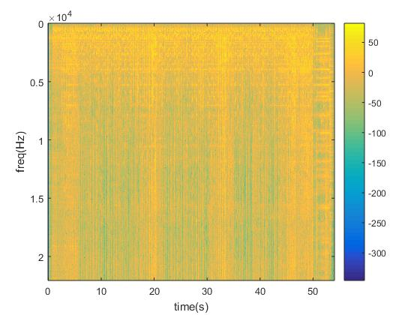

Figure: Spectrogram of the sound file input signal downsampled by 6 (Aliasing is quite observable)

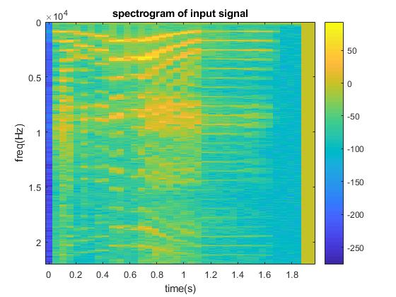

Figure: Spectrogram of the sound file input signal downsampled by 2.5 (A different sound file input is used)

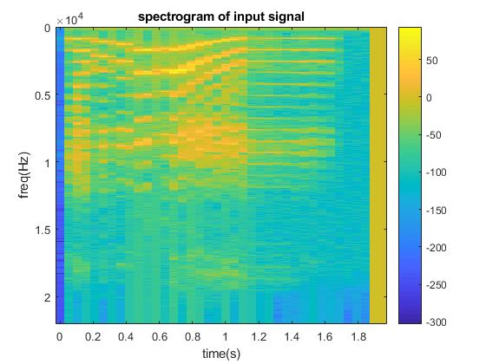

Figure: Spectrogram of the sound file input signal decimated by 2.5 (A different sound file input is used) (Lower magnitude high frequency components)

1. **Recorded signal input:**

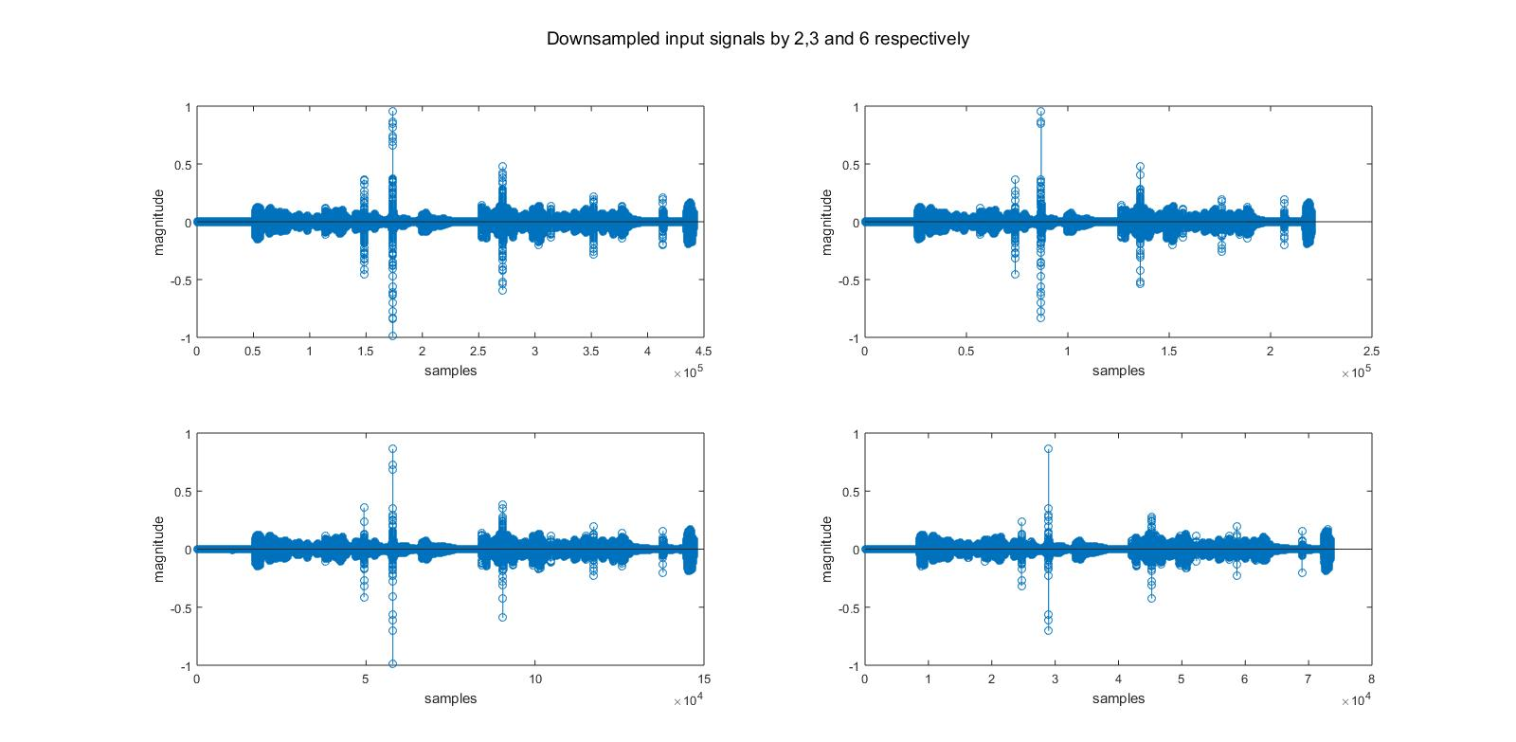

Figure: Time domain representations of the original, downsampled by 2, 3, 6 respectively

* **Recorded signal downsampled:**

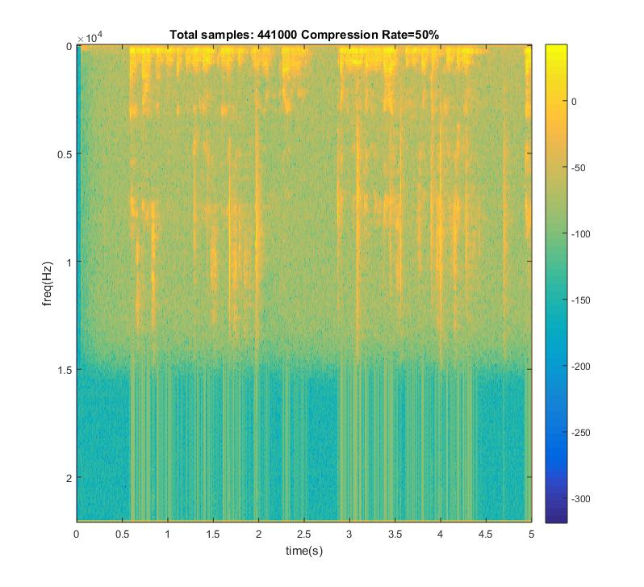

Figure: Spectrogram of the recorded signal downsampled by 2

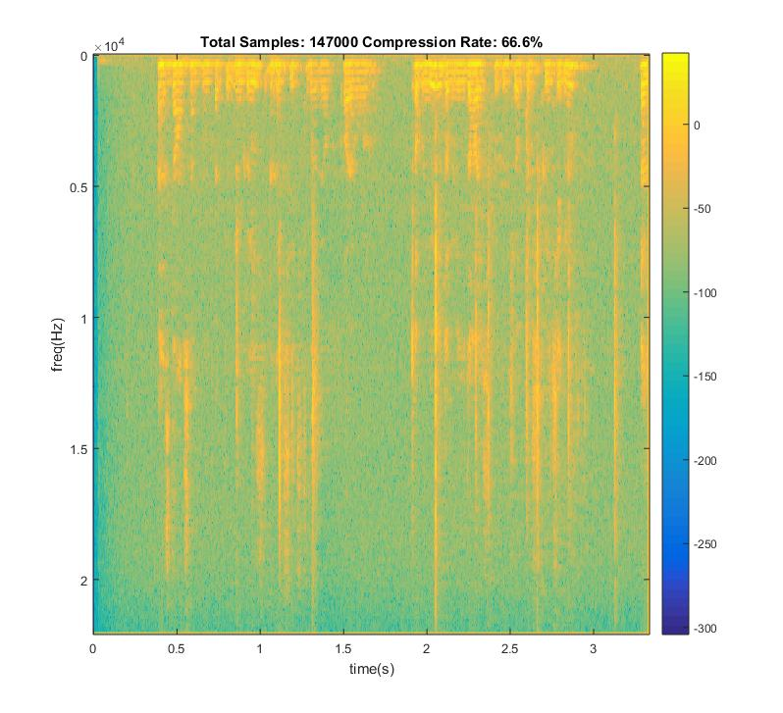

Figure: Spectrogram of the recorded signal downsampled by 3

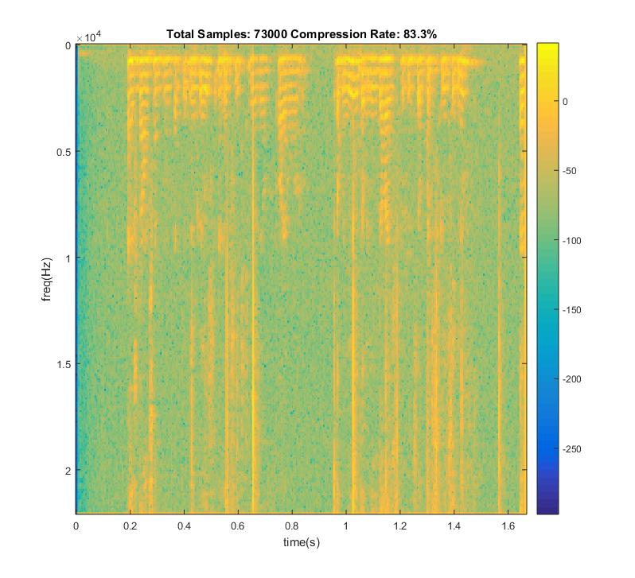

Figure: Spectrogram of the recorded signal downsampled by 6

* **Recorded signal decimated:**

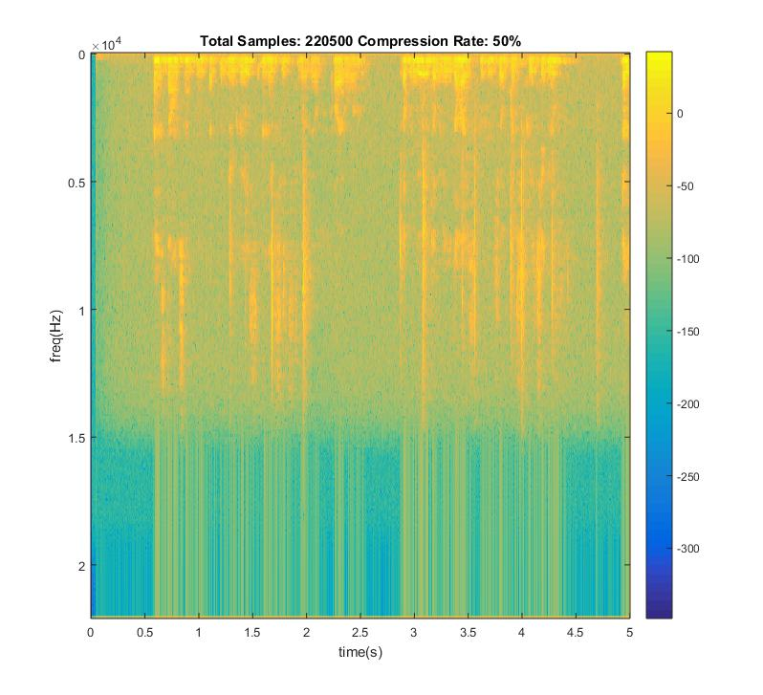

Figure: Spectrogram of the recorded signal decimated by 2

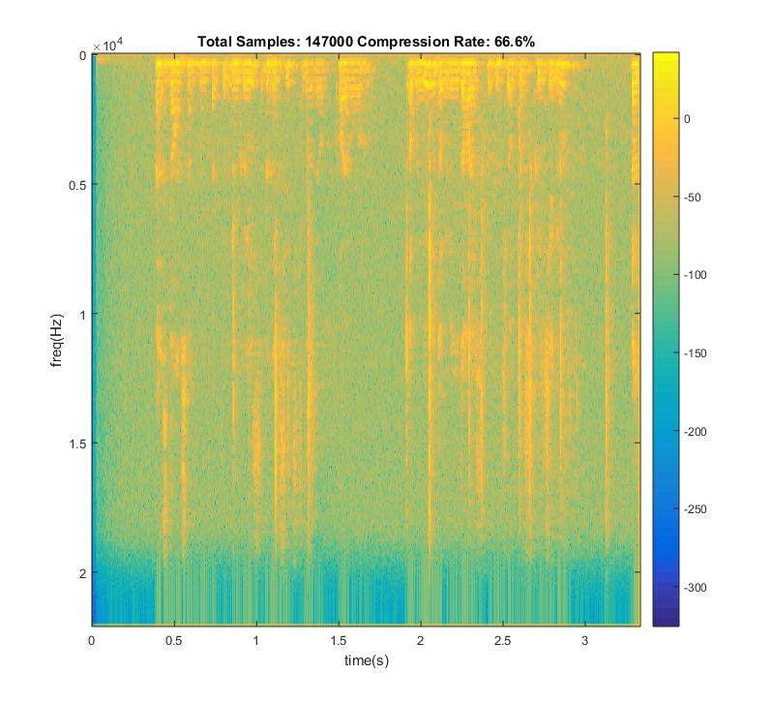

Figure: Spectrogram of the recorded signal decimated by 3

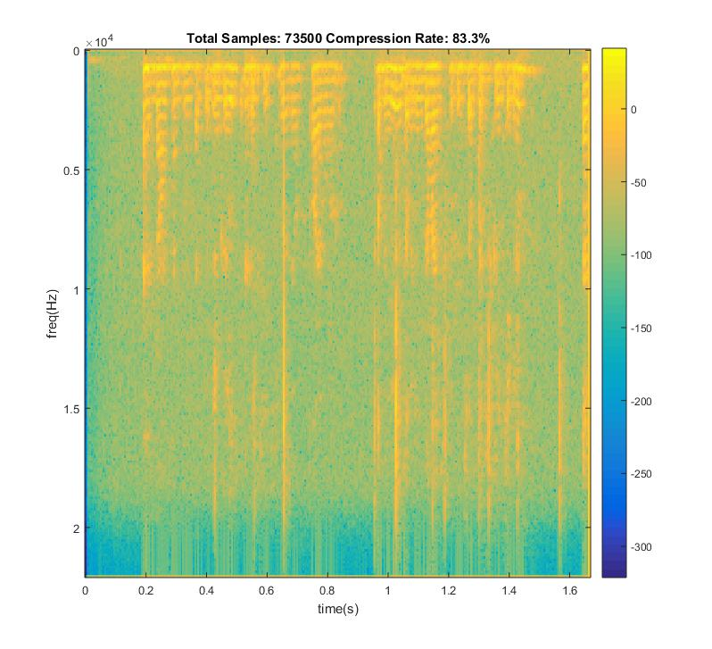

Figure: Spectrogram of the recorded signal decimated by 6

1. **Reducing the Bits Per Sample on Time Domain:**

* Quality of sound signal decreases each time we decrease the bits per sample because quantization error increases.
* For a 48000 sample/second sampling rate, bit rate is 48000(samples/sec)*8(bits/sample)/1024(kbit) =375 kbps.
* If we tried to increase the precision of sampling (such as trying to sample amplitude of signals with floating point precision), more bits per sample should have been stored.
* Quality could be increased by using a non-uniform quantizer by applying Lloyd-Max algorithm , which sets the quantization regions by the distribution of samples. It guesses an initial set of uniform quantization points and it calculates decision thresholds and then, new representative quantization levels by making use of samples’ probabilty function. And this process continues until no further distortion reduction is possible.

**Results:**

For a sinusoidal signal with the formula y=10sin(2π2t) :

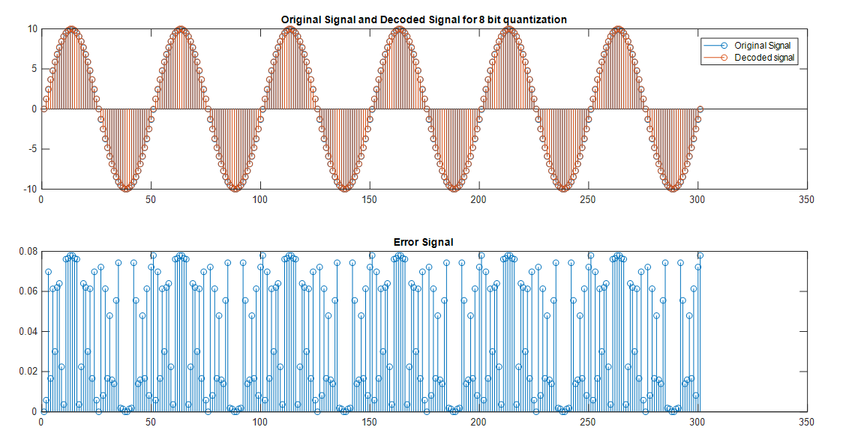

Figure: Original, decoded and error signals for 8 bit quantization for sine

Mean of error signal for 8 bit quantization for sine is 0.0389.

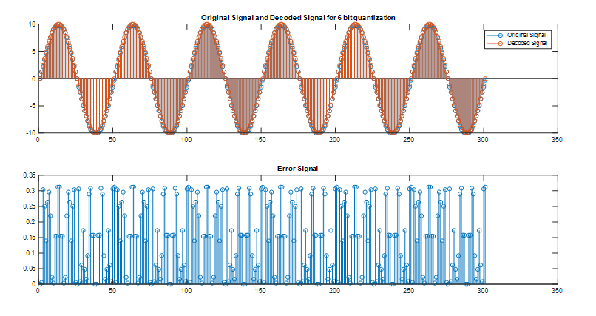

Figure: Original, decoded and error signals for 6 bit quantization for sine

Mean of error signal for 6 bit quantization is 0.1554 for sinusoidal.

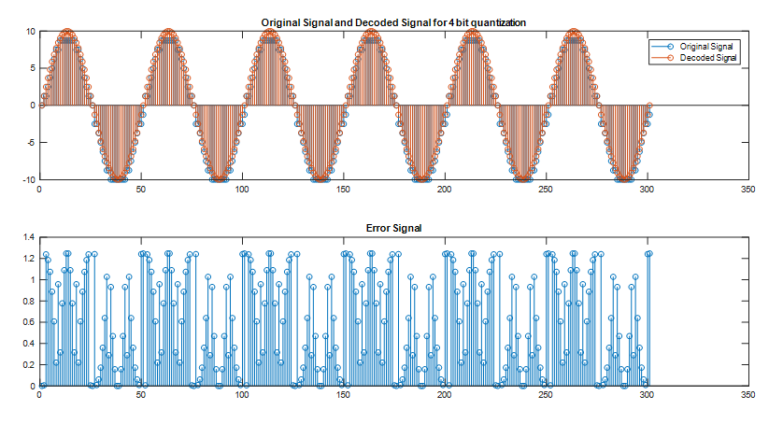

Figure: Original, decoded and error signals for 4 bit quantization for sine

Mean of error signal for 6 bit quantization is 0. 6217 for sinusoidal.

For a song, which we have taken 300 samples from, which is sampled with 44100 samples/second:

Figure : Original, decoded and error signals for 8 bit quantization

Mean of power of error signal for 8 bit quantization is 3.01e-07.

Mean of absolute values of error signal for 8 bit quantization is 2.39e-04.

Figure : Original, decoded and error signals for 6 bit quantization

Mean of power of error signal for 6 bit quantization is 8.24e-07.

Mean of absolute values of error signal for 6 bit quantization is 7.12e-04.



Figure : Original , decoded and error signals for 4 bit quantization

Mean of power of error signal for 4 bit quantization is 8.99e-06.

Mean of absolute values of error signal for 4 bit quantization is 2.6e-03.

As the results show, decreasing the bit numbers for quantization increases the quantization error magnitudes which results in a worse and “quantized” hearing experience.

Resulting number of stored bits for the 5 seconds of the same signal is:

For 8 bit quantization : 48000*5*8= 1920000 bits

For 6 bit quantization : 48000*5*6= 1440000 bits

For 4 bit quantization : 48000*5*4= 960000 bits

1. **Transform Coding:**

**Using DFT:** In this part, quantization is applied to frequency domain coefficients. As indicated in the description of the project, input signal is divided into N partitions and Fast Fourier Transform (FFT) is applied for each partition. After that, coefficients of these partitions are sorted in ascending order and a threshold is determined for them using the total length of partitions. If we call the total length as N and if we want a threshold that makes 90% of the coefficients zero, threshold is decided as the N*(90/100)th element of ascending order sorted coefficient matrix. After deciding on the threshold, elements of the unsorted matrix which are smaller than this threshold are made zero for each partition. Next step is taking inverse fast fourier transform of each partition and concatenating them in the order of how we partitioned the complete signal.

**Using DCT:** Similar to the procedure for DFT, input signal is again divided into N partitions and instead of FFT, DCT-2 is applied for each block and blocks are thresholded according to the desired rate of compression. This is done in a similar way with the previous part. All components are sorted and respective component which has a magnitude larger than required percentage of remaining signal components is selected as the threshold for that block. Then, inverse DCT is computed and concetanation is done.

**Comments and results:**

We can see that DCT has better quality when compared with DFT. This is because of the reason that in DCT low frequency components are emphasized and as we are speech processing it gives much better results. For high compression rates, it is very audible. In the following figures, you can see the error signals of DFT and DCT . **For your convenience, sound signal is multiplied by 108 to see the difference of error signals easier.**

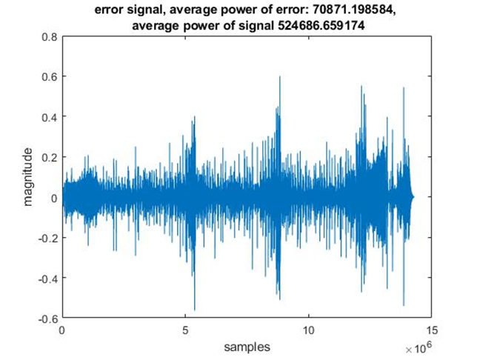

Figure : Error signal of a sound signal compressed with DCT(Blocksize=429 , 99% compression)

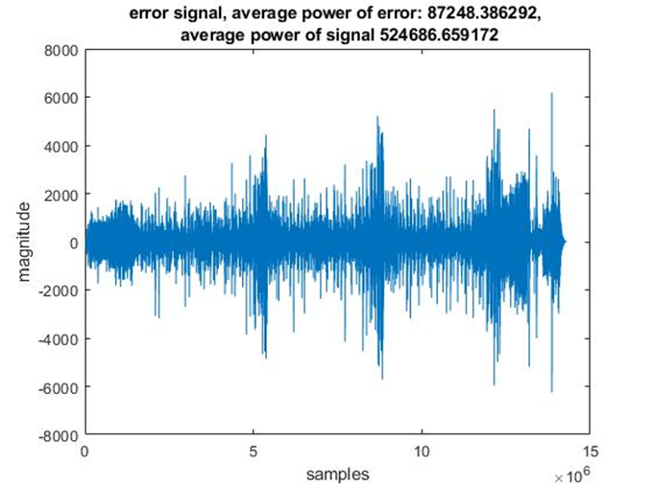

Figure : Error signal of a sound signal compressed with DFT(Blocksize=429 , 99% compression)

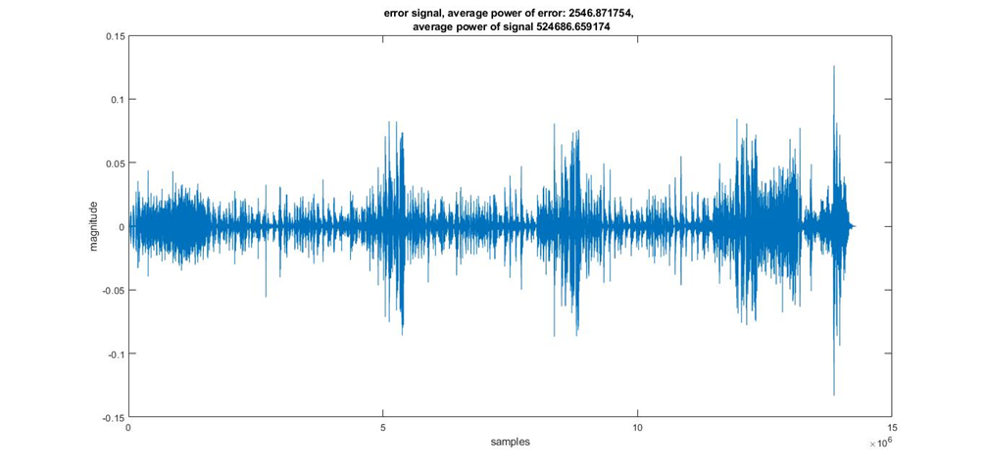

Figure : Error signal of a sound signal compressed with DCT(Blocksize=429 , 90% compression)

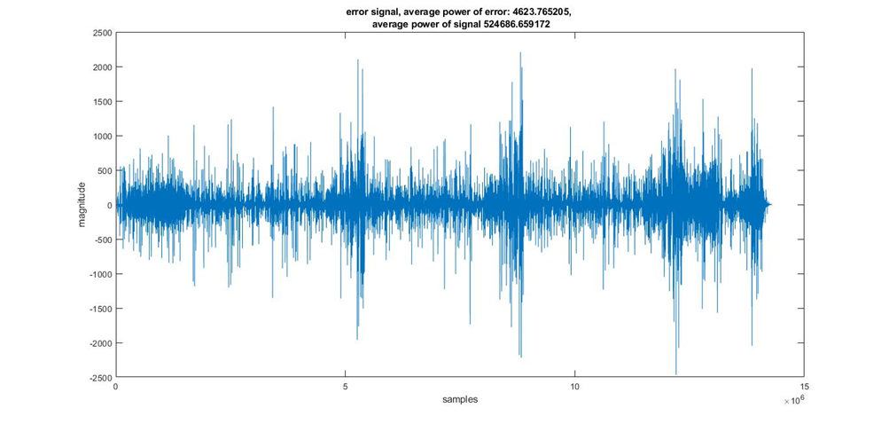

Figure : Error signal of a sound signal compressed with DFT(Blocksize=429 , 90% compression)



Figure : Error signal of a sound signal compressed with DCT(Blocksize=429 , 70% compression)



Figure : Error signal of a sound signal compressed with DFT(Blocksize=429 , 70% compression)

We can see that , more high frequency components exist in the frequency response of DFT and DCT . This is because DFT is calculated with the extension of input signal to make it periodic and artificial discontinuities occur . This is not the case in DCT as DCT makes input signal periodic by adding its symmetric to its right and then shifts it. Therefore in DCT , artificial high frequency components do not appear and it enhances the quality. You can see it in figures below.

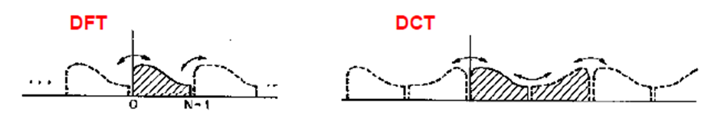

Figure : Comparison of extending methods for DFT and DCT

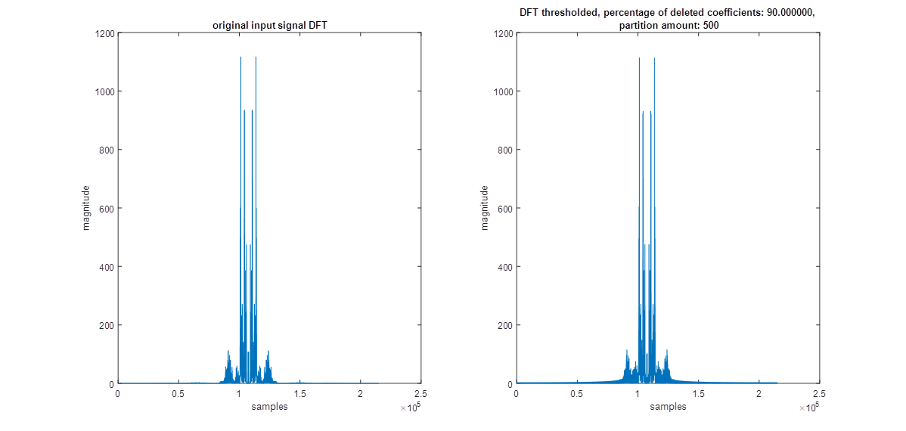

Figure : Comparison of DFTs of original signal and DFT thresholded signal(%90 compression)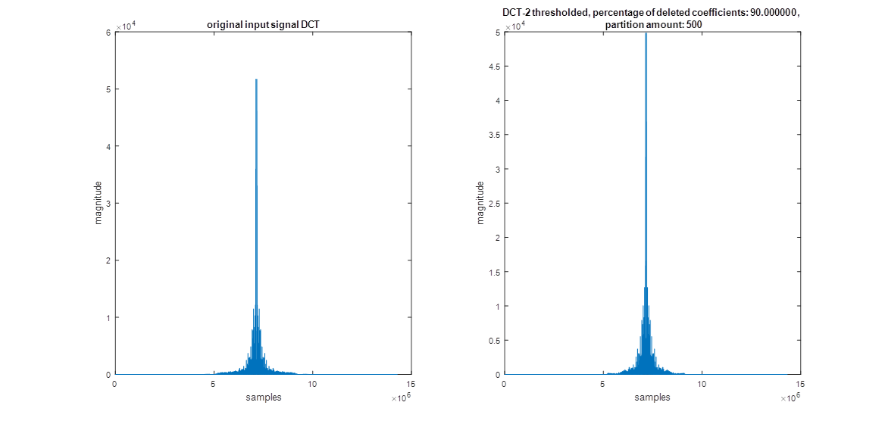

Figure : Comparison of DFTs of original signal and DCT thresholded signal(%90 compression)



Figure : Comparison of DFTs of original signal and DFT thresholded signal(%70 compression)



Figure : Comparison of DFTs of original signal and DCT thresholded signal(%70 compression)

For %90 compression rate and an input signal’s DFT which has 28252*501=14154252 coefficients , number of coefficients set to zero is 12861500 which is approximately 90% of the coefficients. It is nearly the same for DCT as compression rate is the same.

When we increase the blocksize from 429 to 859 (approximately 2 times), errors decrease for every compression rate and compression method (DFT & DCT-2). This makes sense because when we increase the blocksize, we apply compression on a larger portion of the audio signal which means that we take larger amounts of frequency components into account. Due to this fact, suppression of components are done in a more healthy way (components that really has smaller magnitudes among the signal are eliminated instead of components that have smaller magnitudes in an individual partition but spans along the signal with a greater magnitude).

**Results for larger blocksize:**

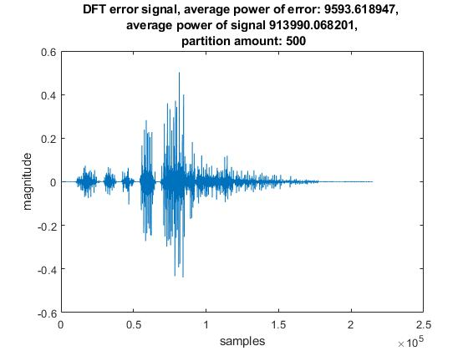

Figure : Error signal of a sound signal compressed with DFT(Blocksize=429 , 90% compression)

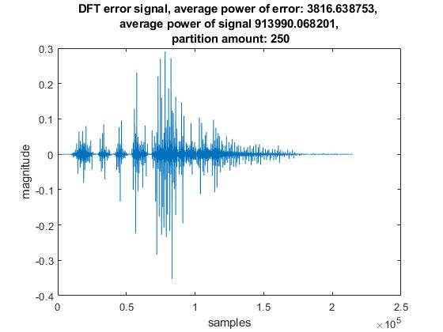

Figure : Error signal of a sound signal compressed with DFT(Blocksize=859 , 90% compression)

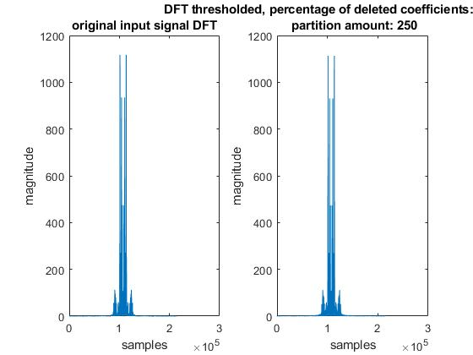

Figure : Comparison of DFTs of original signal and DFT thresholded signal, blocksize = 429



Figure : Comparison of DFTs of original signal and DFT thresholded signal, blocksize = 859

1. **MPEG / Audio Encoder:**

MPEG Layer 3 is an audio coding format for digital audio that quantizes the transform domain coefficients.It reduces the memory requirements to store a sound waveform. In this final part of the project, we were required to complete an unfinished code sequence which takes an input file which has a format “.wav”, compresses and saves it in the format “.mp3”. There are 3 main tasks that should be completed. First task is the prototype filter design.

1. **Prototype Filter Design:** MPEG/Audio encoding algorithm uses subband filtering including a bank of 32 subband filters with real coefficients. These subband filters result in 32 subband signals. These filters cover the entire spectrum from 0 to pi, each spanning pi/32.These filters are identical to each other, only difference between them is that the modulation with a cosine to obtain a shifted version in the frequency domain to span whole frequency range. So, all of them can be obtained from a prototype filter.

As indicated in the project description, this filter is an 512-tap finite impulse response filter, with the desired low pass response. According to the specifications, we have constructed the prototype filter using “firpm” command of MATLAB.

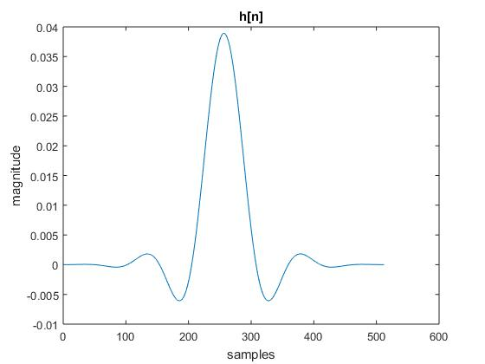

Figure: Time domain plot of the prototype filter

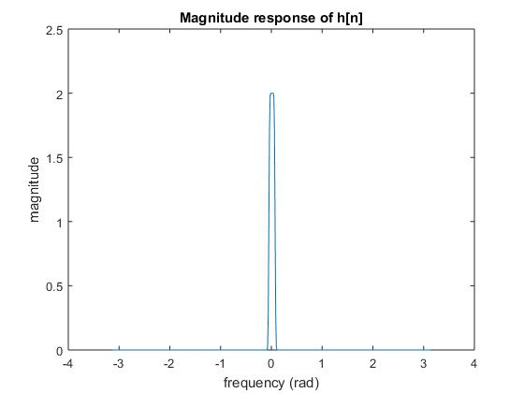

Figure: Magnitude response of the prototype filter

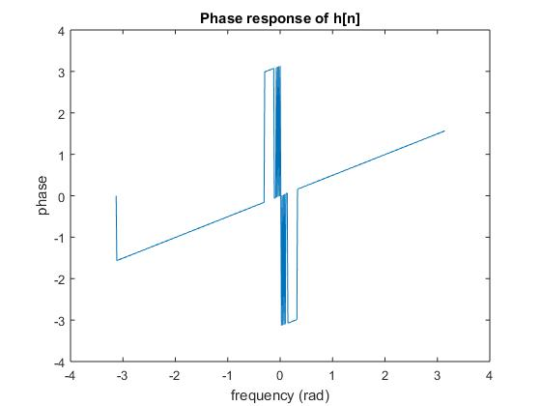

Figure: Phase response of the prototype filter

Prototype filter has linear phase characteristics as it can be seen in the figure.

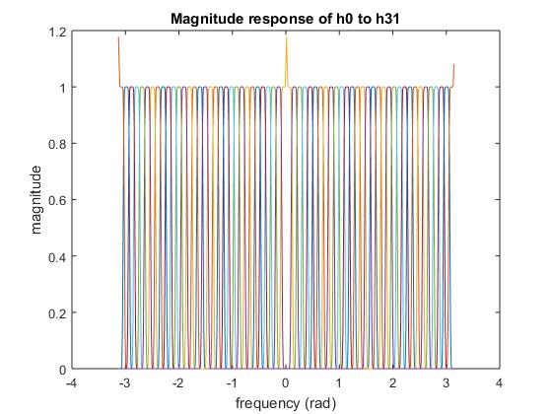

Figure: Magnitude response characteristics of H0 to H31 on a single plot

As it can be seen in the figures, frequency domain characteristics of H0 to H31 covers the entire spectrum since we multiply them with cosines that has frequencies increasing in the order of pi/32.

1. **Subband Filtering:** After applying 32 filters designed in the first part, resulting signals are downsampled by 32. However, applying straightforward convolution is inefficient in terms of computational concerns. Using the fact that hk[n], k=(0,..,31), are simply cosine modulated versions of each other and periodicity of cosine, a computationally efficient version of the operation is obtained by changing the summation index by 2Np+q where N is the order of downsampling and q=0,...,2N-1. Using 512-point circular buffer, subband filtered outputs sk[m] are obtained after downsampling.
2. **Spectrum Estimation:** MPEG encoder algorithm allocates different number of quantization bits for subbands, according to the masking levels of components. These levels are determined by the psychoacoustic model which assigns these bits to the regions with respect to their perceptual importances fot human ears. Subbands that are difficult to perceive are allocated very few bits (Higher frequency subbands). Human ear masks side frequency components near a strong component when it is heard according to the frequency and magnitude of the dominant component. If side components do not exceed the levels of the mask that ears apply, then they can not be heard. This masking gets stronger as the frequency of the strong component increase, meaning that we can not hear multiple high frequency components with different amplitudes in a high frequency subband whereas we can hear close components in the low frequency subbands, dividing the spectrum into approximately 24 critical bands. This leads to the corresponding bit allocation.
3. **Quantization:** Quantizer function that is required to be implemented quantizes the sample according to the required bit number obtained from the psychoacoustic model, quantization parameters and scaling factor which is used to obtain a the reconstructed signal without a magnitude deflection since spectrum estimation is done by scaling all subband signals to 96 dB magnitude. Without this factor, magnitude information of subband signals are lost and compression results in equal magnitudes for all bands which results in a completely wrong signal.

**Comparisons of the input and output signals:**

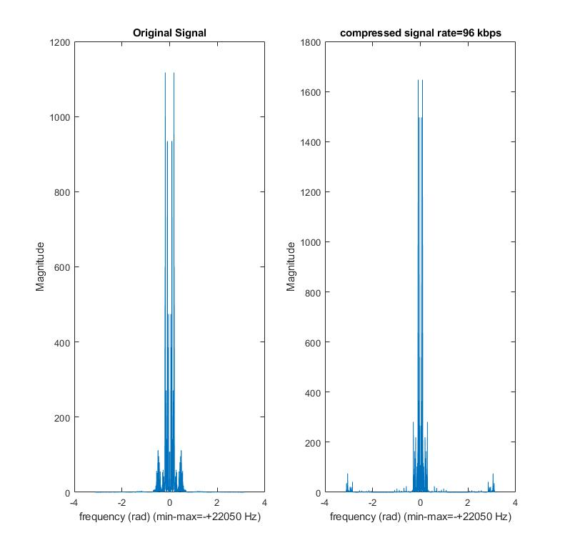

Figure: Magnitude responses (FFT’s) of the original (.wav) and compressed (bitrate=96 kbps) (.mp3) signals

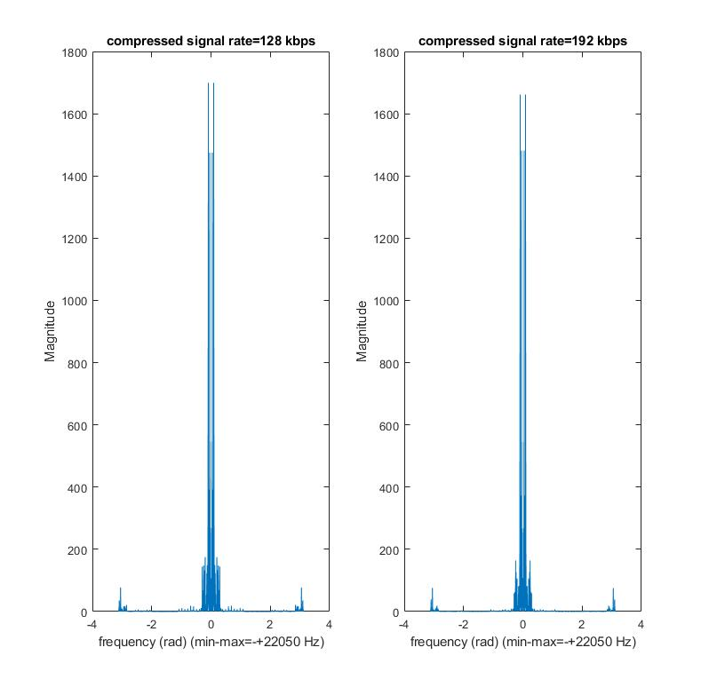

Figure: Magnitude responses (FFT’s) of the compressed signals with bitrates of 128 and 192 kbps respectively

**Comments:**

* As it can also be seen in the magnitude responses of the compressed signals, as the rate of bits per second increase in the compression algorithm, frequency characteristics of the compressed signal resembles more to the original one. This is expected because as the rate of bits per second increase, number of bits used for quantization increase for samples which results in less quantization error.
* MPEG audio encoding also adds high frequency noise to the signal during compression. However, most of this noise is not audible and does not effect the hearing experience of the listener. However, several high frequency peaks gets into the audible spectrum and they are audible.

When we listen the resulting signals, the quality enhancement can be observed. In the 96kbps case, several additional high frequency components, which can be observed in the FFT’s above, can be heard as a robotic distortion. Magnitudes of these components decrease as we increase the kbps and mentioned effects almost vanishes when the rate is 192kbps.

* When compared with the previous methods, (Downsampling, time domain quantization, transform domain thresholding) this approach provides the best results. It applies frequency domain threshold in a better manner than transform coding by taking hearing characteristics of human ear into account instead of crudely eliminating components according to their magnitudes. Also, it does reduction of the total number of bits used to store the data in a much more efficient way according to the resolution of human hearing system by taking the frequency band of the components into account.